Participant Initiated Non-RID Activities
INSTRUCTIONS: Complete the top section of this form in Microsoft Word at the end of the CHIA conference and email it to ridceus@tsid.org along with your attendance documentation. Actual signature is not required. Just type your name on the signature line, save it as a Word file, and send it by email. Hard copies can not be accepted.

(PINRA)

This form will be used if a CMP Participant plans to attend another organization’s workshop, conference, formal in-service training or activity. The RID Approved Sponsor will determine if the activity is appropriate for CEUs.

Participant Name: |  | RID Member Number:

Participant Address:

Email: |  | Phone #

Activity / Conference Name: | CHIA 2021 Connecting Coast to Coast

Activity / Conference Theme or Focus (attach brochure/flyer) | Workshop descriptions already submitted

Dates and Times of activities you will attend: | March 5-6, 2021, workshop lineup already submitted

Total Number of CEUs to be awarded |  |  | Check Content Area: | Professional Studies General Studies
Name and Code of RID Approved Sponsor |  | Texas Society of Interpreters for the Deaf (TSID) 0027

I certify that this activity/conference represents a valid and verifiable Continuing Education Experience that exceeds routine employment responsibilities.

Participant Name (typed) |  | Date:

I certify that I received this activity plan prior to the start of the activity/conference and I agree to sponsor this Continuing Education Experience. I will verify successful completion prior to awarding CEUs.
RID Sponsor Administrator Name: |  | Date:

This section should be filled out and signed upon completion of the activity/conference:
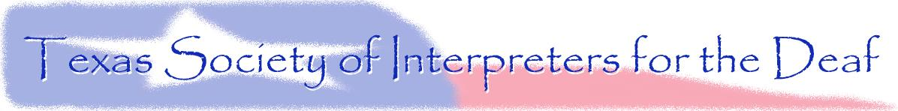
Activity Code Number: |  | CEUs Awarded:

I have verified that the Participant attended this activity/conference and that the activities listed are appropriate educational experiences which should be awarded the number of CEUs denoted above.

RID Sponsor Administrator: |  | Date:

The Participant must send documentation of attendance to the Sponsor upon completion of the activity. The Sponsor must complete and mail this form to the national office within 45 days of the completion of the activity/conference. Updated July 2005

